12th grade World Literature Spring Project
Create your own comic strip: A book project for Maus I by Art Spiegelman

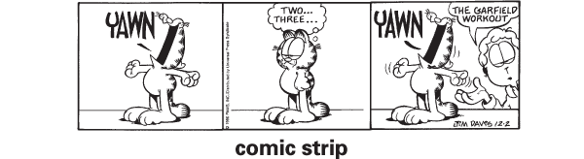

Due: Thursday, February 22, 2018

Art Spiegelman’s Maus depicts the Holocaust in graphic form. It uses images and words to convey Art’s father’s experience as a Polish Jew during World War II, as well as Art’s own difficult relationship with his father. Within Maus is another comic, “Prisoner on the Hell Planet,” that tells of Art’s struggle after his mother commits suicide.

The novel and the comic within it are examples of how comics can be used not only to portray humor, but also to tell serious and often painful stories. Your job is to create your own comic depicting a serious or perhaps painful story from your own life or from your family’s history. While the comic should be about a difficult event or circumstance, rather than a humorous one, do not feel pressured to write about anything you do not feel comfortable sharing.

This 50-point major project will have two parts:

1. A comic strip at least 6 panels long (30 points):
a. Comic should tell a serious story from your own life or family history
b. Must use words and images to tell your story
c. Images can be hand drawn, sourced from clip-art, or created on a computer
d. Keep the format in black and white.
e. Use frames, narration boxes, and text bubbles.
f. Submit on ½ size poster board.

Maximum 30-pt grade depends on seriousness of theme and use of creativity: close-up, long-shot, aerial view, text bubbles, narration, number of characters per frame, use of frames, quality and quantity of art and text, overall neatness, and following all directions.

2. A one page typed, double spaced reflection (20 points) addressing the following four prompts in paragraph form worth 5 points each:
a. Why did you choose this story to tell?
b. Compare the comic format with a traditional text format: what were you able to convey in your comic that would have been difficult to do with just text? What would have been easier to convey in writing?
c. If you were going to publish this story, do you think a comic would be the best medium for telling it, or would a different format work better—and why?
d. Using specific examples from Maus and your own experience, analyze Spiegelman’s decision to use the graphic novel format: What does the graphic novel format add to his story? How does it increase your understanding of the Holocaust?

