Journal Prompts



**2**

**1**



[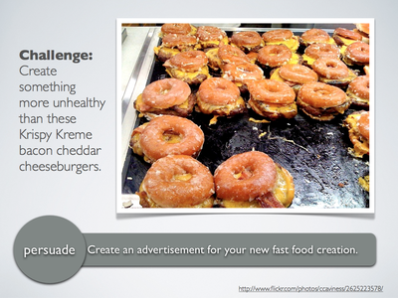](http://visualprompts.weebly.com/uploads/2/5/2/2/25222088/_4560258_orig.png)[](javascript:window.jQuery.fancybox.jumpto(48);)[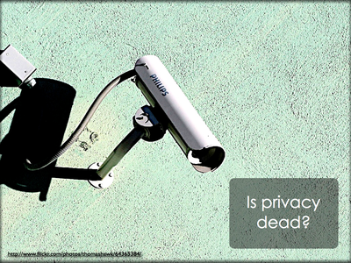](http://visualprompts.weebly.com/uploads/2/5/2/2/25222088/_1905070_orig.png)

**6**

**5**

**4**

**3**